Title of the Paper
First and last Name
Abstract (no less than 200 and no more than 250 words)
Research aims :
Research approach and methods:
Results:
Practical and research implications:
Originality and value:
Keywords: keyword 1, keyword 2, keyword 3, keyword 4, keyword 5

- Introduction
Rationale for study, aim and research question(s), gaps must be identified/ pertinent literature is reviewed, research reviewed and critiqued, essential terms defined.

- Literature background

Demonstration of an adequate understanding of the relevant literature, up to date sources, do not ignore significant work(s), use high-quality sources indexed by Web of Science, Scopus and/or Google Scholar.

- Research approach and methods
Describe sample, data-gathering methods, the procedures and analytic technique(s) should be described, the general research approach and process must be presented.
- Discussion and results
Please, comment whether the results are made properly, compared and contrasted with relevant literature conclusions drawn logically, tables and figures elaborated and discussed correctly. The tone of the article displays an unbiased, impartial scientific attitude)
- Conclusions
Conclusions should be related to the aim and research questions, hypotheses, implications for theory and practice and directions for further research are introduced, limitation of the analysis is presented.
- Acknowledgments (if any)

- References (very rigorously written in APA Style 6th ed.)

Notes: et al., is used after the first full citation (up to 5 authors), we use coma before & when we have 3 authors or more (eg., Author1, Author2, & Author3). Do not use initials before last names.
Biographical note(s) at the end of the text.

Tables (open) and Figures must be in the text. Do not use abbreviations. Inside the text should be written Table 1 or Figure 1 numbered subsequently.

Table 1. Title of the table
Text | Text | Text
Text  Text  Text  Text  Text  Text | Text  Text  Text  Text  Text  Text | Text  Text  Text  Text  Text  Text
Text | Text | Text
Source: Kowalski (2006).

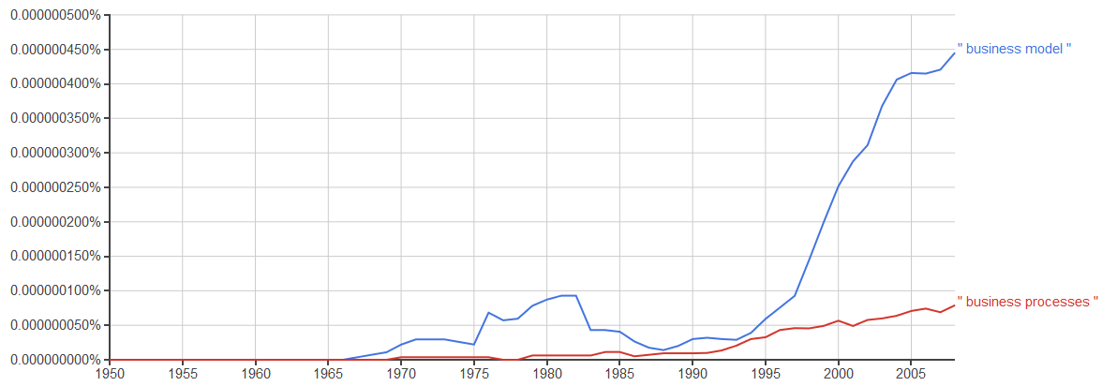
Figure 1. Business model and business processes trends
Source: based on Google Ngram Viewer.

First and last name, Title, Position, Department, University or Institution, Street with no., Town with code, Country, e-mail: name@surname.com (Orcid ID).

